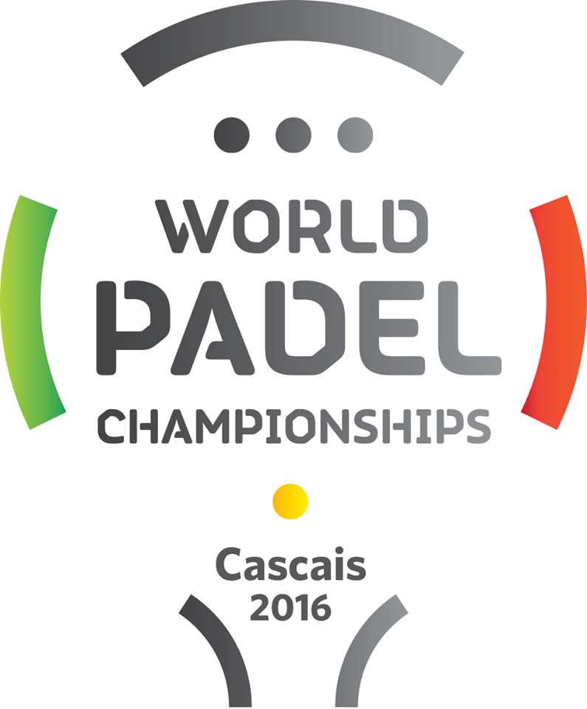

HOTEL |  |  | B&B | 14 |  | 15 |  | 16 |  | 17 |  | 18 |  | 19
Sheraton Cascais Resort (5*) |  |  | 120.00 €
Quinta da Marinha (5*) |  |  | 120.00 €
Vila Galé Cascais (4*) |  |  | 80.00 €
TICKETS |  |  |  |  | 14 |  | 15 |  | 16 |  | 17 |  | 18 |  | 19
 |  | Type “X” on the days you want to book. |  |  | 40.00 € |  | 40.00 € |  | 40.00 € |  | 40.00 € |  | 60.00 € |  | 80.00 €
Premium Seats*
Corporate Box** |  |  |  |  | Monday to Saturday (14/11 to 19/11) |  | Type “X” to book:
BOOK YOUR HOTEL & PREMIUM SEATS / CORPORATE BOX NOW!

Warning: these prices (with 20% discount) are only available with Hotel reservation.

*Access to Padel Club, VIP area with open bar.
**Corporate Box: 6 seats, access to Padel Club, open bar. 6 daily meals included at Padel Bistrô.

PAYMENT METHOD
Please fill the following table with your payment method info:
Name
Card number
CVC
Card expiry date

